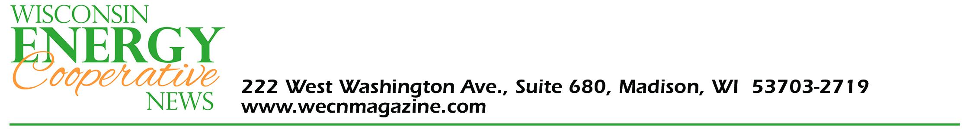

FOR IMMEDIATE RELEASE

Friday, August 27, 2021

Wisconsin Energy Cooperative News
222 W. Washington Ave., Suite 680
Madison, WI 53703-2719
www.wecnmagazine.com
CONTACT: Dana Kelroy, Editor, dana@weca.coop or 608-467-4645

Bayfield Electric Cooperative wins statewide magazine award

Bayfield Electric Cooperative recently won an award of excellence for presentation of local news in the Wisconsin Energy Cooperative News, the voice of the state’s rural electric cooperatives. Briana Green, accounting assistant at Bayfield Electric Cooperative, is the editor of the co-op’s local pages within the magazine. Awards were presented at the 2021 Electric Communicator’s Conference in La Crosse August 25.

Bayfield Electric Cooperative’s magazine pages were adjudged to have been the best overall in the category of Energy Education for the previous year.

Founded in 1940, the Wisconsin Energy Cooperative News focuses on statewide issues that affect electric cooperatives, promoting the general welfare of Wisconsin’s electric cooperatives, their member-owners, and the areas they serve. Nineteen electric cooperatives throughout the state are responsible for their own local sections within the magazine, which reaches 152,000 mailboxes each month.

# # #

